Decision Making Statement
_______________________________________________________________________________
Decision making statement is used for to work with conditional programming.

There are five types of decision making statements
1. Simple if
2. If else
3. Else if ladder
4. Nested if statement
5. Switch statement

Simple if Statement
__________________________________________________________________________________
Syntax:

if( condition )
{
Write here your logics
}

Write here other logics

Example: WAP to input two values and check which is greater.
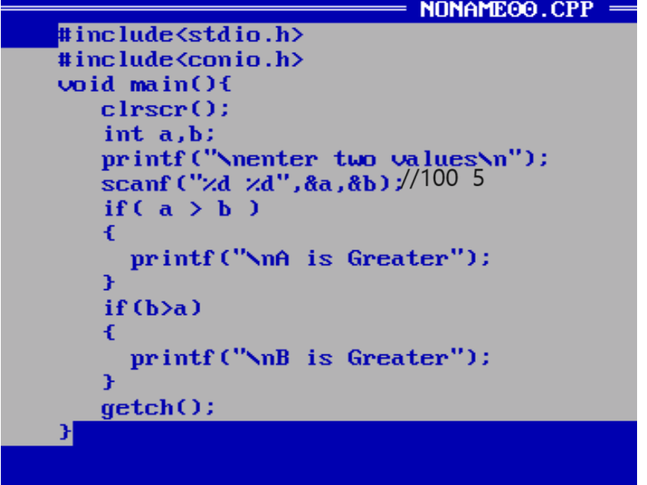

If else statement
____________________________________________________________________________
If else statement is used for when we have two conditions exact opposite of each other then we can use if else statement.

Syntax:
if( condition )
{
write here true logics
}
else{
write here false logics
}
other logics

Example: WAP to input number and check number is even or odd.
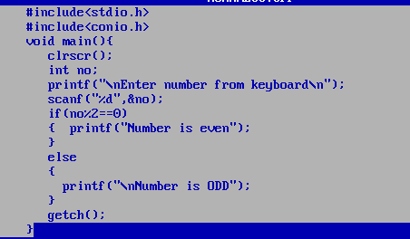

Example: WAP to input unit of electricity meter and per unit rate of electricity meter and calculate its total bill and if bill amount is more than 2000 then give discount on bill 10% if bill amount is less than 2000 then give discount 5%

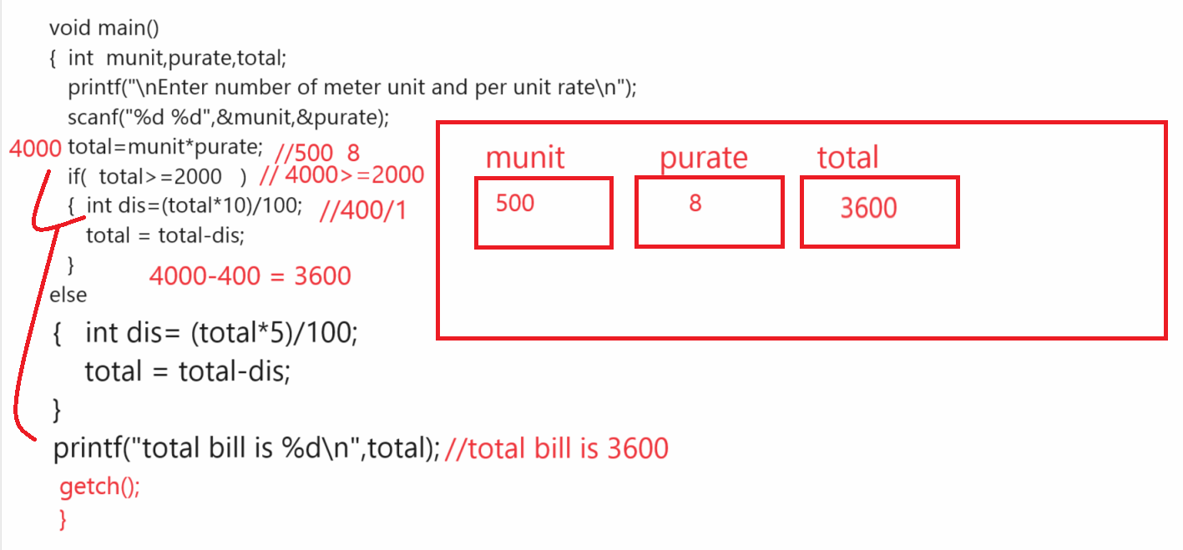
Example: WAP to input character from keyboard and convert lower case character to upper case or upper case character to lower case.

Input Character from keyboard: A
Output: After conversion: a

If we want to work with character operation or character data type we need to use ASCII code.

Q. what is ASCII code?
______________________________________________________________________
ASCII stands for American standard code for information and interchange called as ASCII.
ASCII is intermediate language where every key on keyboard consider as digit in memory or in system.

There are total 256 ASCII code in c language
_______________________________________________________________________________

0- 48 to 9 – 57
A=65 to Z= 90
a=97 to z = 122

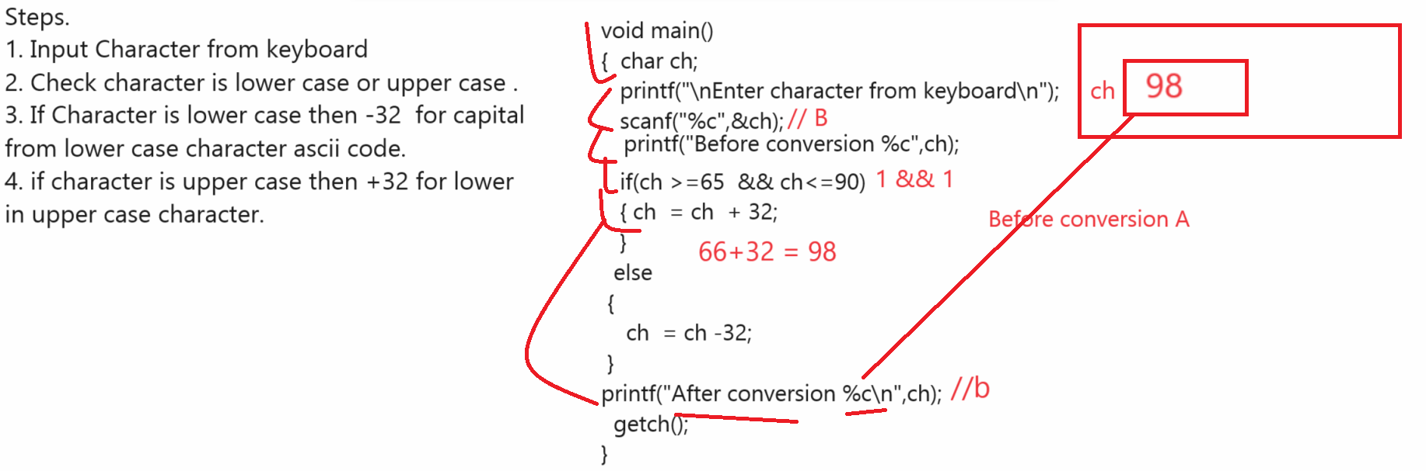

Else if ladder statement
____________________________________________________________________________________
Else if ladder statement is used for when we have multiple conditions and every condition want to work individual condition then we can use else if ladder statement.

Syntax:
if(condition){
write here your logics
}
else if(condition){
write here your logics
}
else if(condition){
write here your logics
}
else{
write here your logics
}

Example: WAP to input three values and check which is greater using else if ladder.
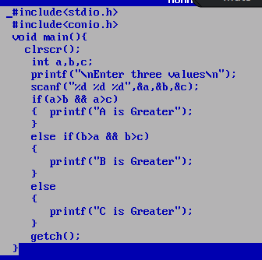
Example: WAP to input character from keyboard and check character is digit, alphabet or special symbol

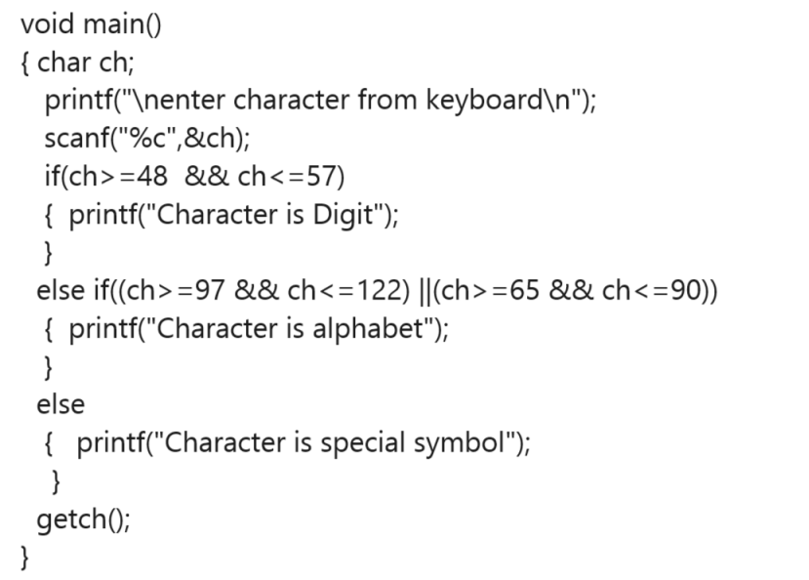

Example:
A washing machine works on the principle of Fuzzy System, the weight of
clothes put inside it for washing is uncertain But based on weight measured
by sensors, it decides time and water level which can be changed by menus
given on the machine control area.
For low level water, the time estimate is 25 minutes, where approximately
weight is between 2000 grams or any nonzero positive number below that
For medium level water, the time estimate is 35 minutes, where
approximately weight is between 2001 grams and 4000 grams.
For high level water, the time estimate is 45 minutes, where approximately
weight is above 4000 grams
Assume the capacity of machine is maximum 7000 grams
Where approximately weight is zero, time estimate is 0 minutes.
Write a function which takes a numeric weight in the range [0,7000] as input
and produces estimated time as output is: “OVERLOADED”, and for all other
inputs, the output statement is
“INVALID INPUT”.
Input should be in the form of integer value –
Output must have the following format –
Time Estimated: Minutes
Example:
• Input value
2000
• Output value
Time Estimated: 25 minute

Source code

#include<stdio.h>
#include<conio.h>
void main(){
clrscr();
int weight;
printf("\nEnter weight of cloth\n");
scanf("%d",&weight);
if(weight>=1 && weight<=2000)
{
printf("time required 25 minutes\n");
}
else if(weight>=2001 && weight<=4000)
{
printf("time requried 35 minutes");
}
else if(weight>=4001 && weight<=7000)
{
printf("Time required 45 minutes");
}
else if(weight>7000)
{ printf("Overloaded");
}
else if(weight==0)
{
printf("Zero time required\n");
}
else
{ printf("Invalid input");
}
getch();
}

Example
___________________________
There is a JAR full of candies for sale at a mall counter. JAR has the capacity
N,
that is JAR can contain maximum N candies when JAR is full. At any point of
time. JAR can have M number of Candies where M<=N. Candies are served to
the customers. JAR is never remain empty as when last k candies are left. JAR
if refilled with new candies in such a way that JAR get full.
Write a code to implement above scenario. Display JAR at counter with
available number of candies. Input should be the number of candies one
customer can order at point of time. Update the JAR after each purchase and
display JAR at Counter.
Output should give number of Candies sold and updated number of Candies in
JAR.
If Input is more than candies in JAR, return: “INVALID INPUT”
Given,
N=10, where N is NUMBER OF CANDIES AVAILABLE
K = 5, where k is number of minimum candies that must be inside JAR ever.
Example 1:(N = 10, k = 5)
• Input Value
o 3
• Output Value
o NUMBER OF CANDIES SOLD : 3
o NUMBER OF CANDIES AVAILABLE : 7
Example : (N=10, k<=5)
• Input Value
o 0
• Output Value
o INVALID INPUT
o NUMBER OF CANDIES LEFT : 10

